10.46:
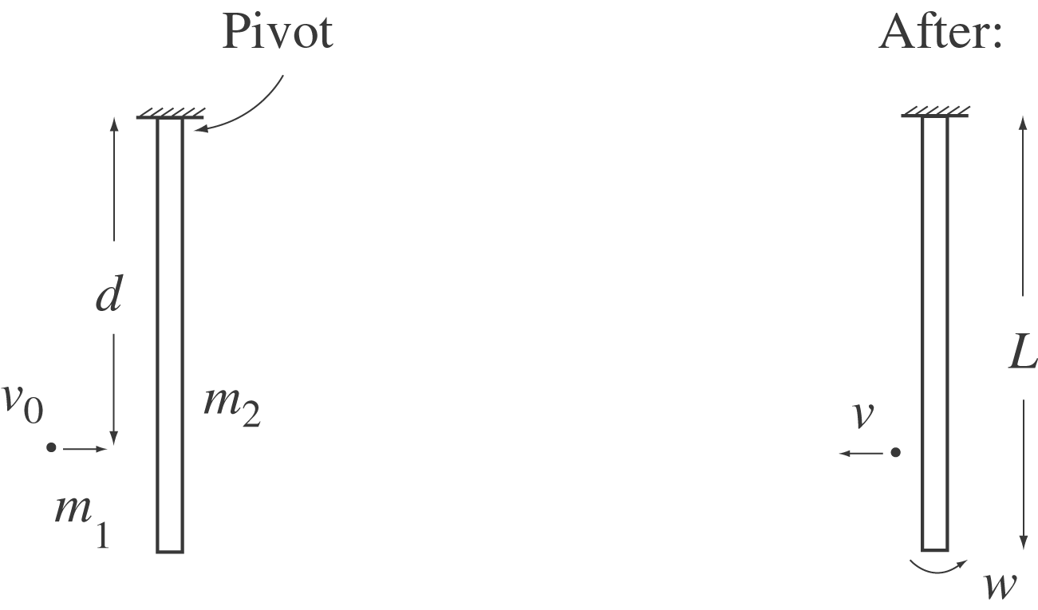

- Conservation of angular momentum:

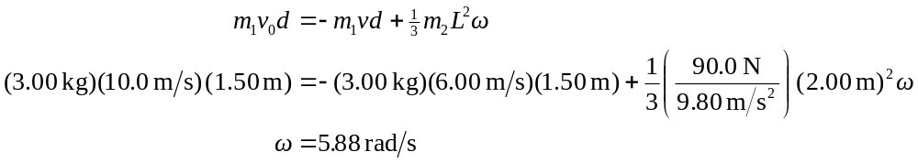

(b) There are no unbalanced torques about the pivot, so angular momentum is conserved. But the pivot exerts an unbalanced horizontal external force on the system, so the linear momentum is not conserved.

